
Mount Waverley Water Main Renewal Project
Site Compound Establishment and Start of Works
Melbourne Water is replacing a section of the ageing water main between Mount Waverley Reserve to the pipe track near the corner of High St Rd and Blackburn Rd
In preparation of our construction works, our delivery partners Safety Focused Performance -JV will be establishing their site facility at the Mount Waverly Reserve Oval and the public tennis court.
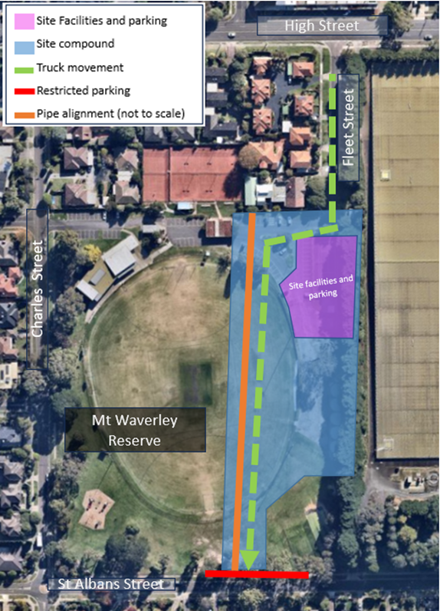
In preparation for construction works, vegetation removal will commence from Monday 7 August 2023.Works to establish the site compound are scheduled to start the week of Monday 14 August 2023.
Stage 1 of the construction for the Mount Waverley Water Main Renewal Project is expected to begin from Monday 4 September 2023. These works will require half of the Mount Waverley Reserve car park and oval to be closed. These works are expected to be completed by the end of October 2023.

Installation of the new water main
We will be excavating two to three meters deep to install new steel pipes that are 80-centimetre in diameter. These pipes will range from six to eight meters in length.
Figure 1: Project Site (facilities and parking)

What to expect
- Traffic flow - increased construction vehicle movements on St Albans Street and Fleet Street. Traffic management will be in place to help you safely move around the area. Please follow the signs and any directions from the traffic control staff.
- Parking spaces on St Albans Street fronting the site will be reduced to allow for large construction vehicles to enter/exit.
- Dust – You may notice some dust while we work, we shall use water carts and street sweepers to minimise dust and mud impacts.
- Noise associated with earth moving equipment being used on site.
- Vegetation removal to prepare for the construction site.
- Temporary footpath closures - Signage will be placed to safely guide you through the area.

Temporary changes to parking
The parking spaces on Fleet Street will remain open throughout these works for local traffic including residents and visitors of the Waverley Community and Learning Center. Temporary disabled parking will be installed at this location. There will be no vehicle access within the work zone.
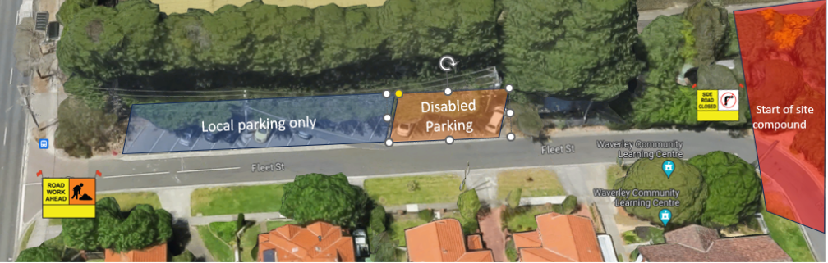
There will be limited on- street parking available in the neighbouring streets for both residents and businesses.

Working hours
Figure 2: Changed parking conditions.
Works are scheduled to take place between Monday to Friday, 7am-6pm, and Saturday 7am to 1pm. This is in line with EPA Guidelines.
Prior notification will be provided if works are to occur outside these standard times.


